2026 Local CIL Funding – Application Form
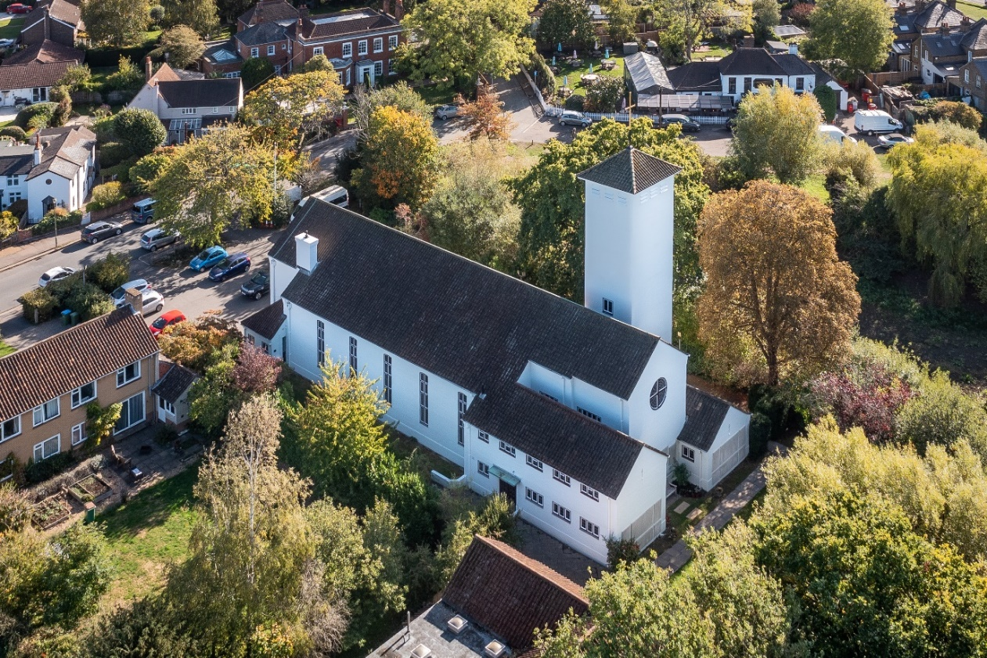
Repair and repainting of All Saints Weston Church, Grade II listed building

Applicants are advised to read the Guidance Notes carefully before completing the Local CIL Funding Application Form.
Completed application forms and supporting documents must be submitted to cil@elmbridge.gov.uk by midnight on Sunday 15 March 2026. Applications received after this date will not be considered


Contents

Application Form 3
Table 1 - Project Funding Breakdown 8
Declaration 9

Application Form
Question | Response
1. Applicant / Organisation
2. Name and position of main contact
3. Applicant’s contact details (email, phone number)
4. Type of organisation (if a charity, please provide registration number)
5. Is the organisation able to reclaim VAT for this project?
5a. Does the organisation have a bank account under the organisation’s name?
6. Project name
7. Address of project (including postcode)
Please provide a map clearly showing the location of the project.
8. Project proposal – Brief and concise summary of the proposed project.

9. Owner’s consent
Please provide written confirmation from the landowner / landlord that their consent to the proposed project has been obtained.
Please check if any additional fees or legal costs are required to complete the work.
10. Estimated project cost (detailed breakdown of the total project cost, specifying which elements the requested CIL funding will cover)
Please provide three competitive quotes for the proposed work
11. Complete Table 1 (under question 21) to show the project funding breakdown, including the amount of CIL funding requested and any other contributions.
12. Why is CIL funding being sought? Please include details on how it would be used and the benefits it will bring.
13. Details of any additional contributions allocated to this scheme.
Please include information on funding sources already explored or applications submitted for other financial support.
14. Indicate whether the applicant or organisation has previously received CIL funding. If so, specify the year it was awarded and the amount received.
14a. Indicate whether the applicant or organisation has previously received funding from other sources. If so, provide details including the year, the amounts received, and the funding organisations.
15. How does the project help to mitigate the impact of new development in the area, support growth and deliver benefits to the community?
If applicable, provide supporting evidence to demonstrate these outcomes.
16. How has the project been assessed in terms of sustainability, climate change, and carbon reduction?
If applicable, please include examples of how the project addresses or mitigates potential environmental and sustainability impacts.
17. Is there any evidence of community support for this project?
Has an initial engagement been undertaken?

18. Proposed project timeline, including key milestones.
Please take into account any external factors that may impact deliverability.
19. Does the project involve any associated revenue expenditure (i.e. day-to-day running costs) If so, please explain how these costs will be funded.
20. If the organisation is not in the public sector, please provide detailed information regarding its financial status.
Please provide a copy of the most recent audited financial statements, including a breakdown of unrestricted reserves.
21. Is planning permission required to carry out the work?
If so, we advise securing approval prior to applying for CIL funding.
If relevant, please provide the application number or indicate the current stage of the planning permission process.
Table 1 – Project funding breakdown:
Contribution type | Amount | Detail
CIL funding sought
Local authority contribution
Third party contribution
Total cost of project

CIL Funding Application Form requirements – application checklist:
□ Guidance notes for the application form have been read
□ Competitive quotes for work provided
□ Location plan provided
□ Landowner / Landlord consent provided
□ Audited accounts (where relevant) provided

Declaration
When you have completed the application form, please read and sign the declaration below and submit the application form as directed.
To the best of my knowledge the information I have provided on this application form is correct.
If Elmbridge Borough Council agrees to release funds for the specified project, these funds will be used exclusively for the purposes described in this application form and agreed in the minutes of the Local Spending Board. In such an event, I agree with the proposals set out above. When requested, I agree to provide the Council with all necessary information required for the purpose of reporting on the progress of or otherwise of the identified project. I recognise the council’s statutory rights as the designated CIL Charging Authority, which includes provisions to reclaim unspent or misappropriated funds.
Privacy Notice: By signing this form, the applicant agrees to Elmbridge Borough Council checking all supplied information for the purpose of informing decision making. The information on this form will be stored in the council’s Infrastructure Spending Board manual filling system and summarised in the Council’s ICT system for the sole purpose of fund processing, analysis and accounting. Information about the project may be publicised on the Council website and in public material for publicity purposes. Personal data will not be disclosed without any prior agreement of those concerned, unless required by law. For further information on the Council’s privacy policy, please see: https://www.elmbridge.gov.uk/privacy-notices/

Signed:
Organisation:
Date:

All organisations involved with the application will need to sign and date the form.
Signed:
Organisation:
Date:

