# Method Statement Form

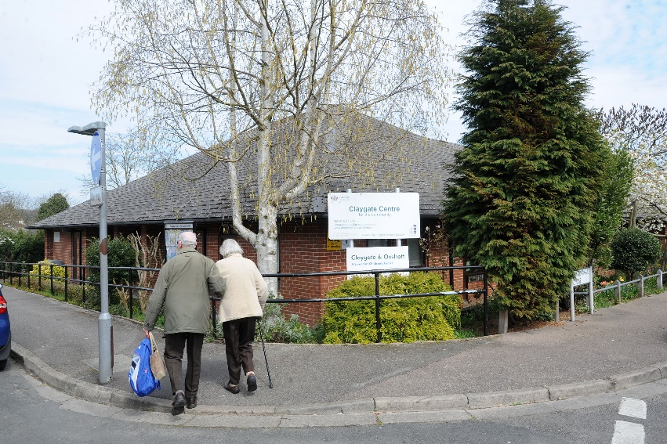

For all hirers at Centres for the Community to accompany a risk assessment



Name of hirer:

Name of company if applicable:

Centre for the Community attended:

|  |  |
| --- | --- |
| Brief description of hire – i.e., Yoga Class for Children |  |
| Operating procedure: i.e “Room to be cleared and inspected, set up mats for instructor and children, welcome and register, settle group, class to be delivered by 1 instructor located at the front of the room for demonstrations, moving throughout during poses to support. Session ends with 1 minute meditation, children return mats to the instructor, parents collect. Room tidied and equipment stored.” |  |
| Named person responsible (e.g., in case of injury / illness). |  |
| Total number of staff present at any one time (this may be a minimum / maximum) |  |
| Total number of staff present at any one time (this may be a minimum / maximum) |  |
| Total number of clients (this may be a minimum / maximum) |  |
| Ratio of staff to clients |  |
| Client specific needs (i.e dementia patients, elderly, if children then age ranges) |  |
| Timing of events and duration. |  |
| Dates for events / Regularity of event |  |
| Table and chairs (centre owned) required: No / Yes – if yes please ensure to include manual handling in your Risk Assessment |  |
| Food preparation (non-commercial) No/Yes – if yes please detail how this will be dealt with in your Risk Assessment |  |
| Use of hirer owned PAT tested electrical equipment: No / Yes – if yes please supply inspection / testing regime in Risk assessment |  |
| Liquids allowed during hire (i.e. drinks) - No / Yes – if yes please ensure to include slips and spillages in your Risk Assessment |  |
| Safeguarding / DBS required: No / Yes – if yes please ensure to include this in your Risk Assessment |  |
| Storage of materials required: No / Yes – if yes please detail what is to be stored. |  |
| List of equipment being brought into centre as part of hire i.e. portable music devise, exercise equipment |  |
| Location in the Centre i.e. gym / main area / other |  |