# 2025 Local CIL Funding – Application Form

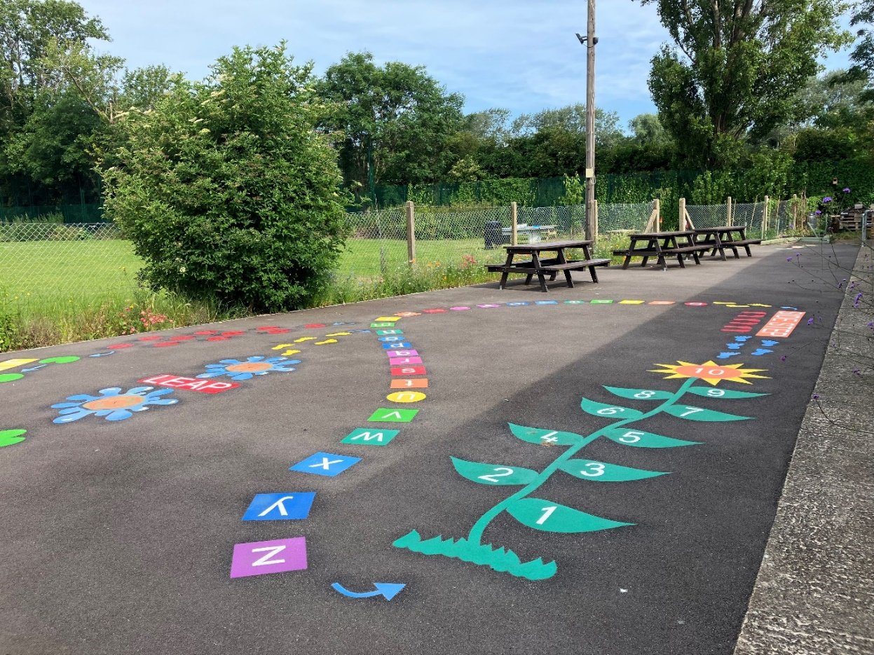

New resurfaced patio with playground marking at Lower Green Community Centre, Esher – Local CIL Funding 2023.

Please read the 2025 Local CIL Funding: Guidance Notes for Applicants before completing this form.

Please return your completed application forms and supporting information to: cil@elmbridge.gov.uk by **midnight on Sunday 16 March 2025.**



Contents

2025 Local CIL Funding – Application Form 1

Application Form 3

Table 1 - Project Funding Breakdown 8

Declaration 9

## Application Form

|  |  |
| --- | --- |
| Question | Response |
| 1. Applicant / Organisation. |  |
| 2. Name and position of main contact. |  |
| 3. Applicant’s contact details (email, phone number, and address). |  |
| 4. Type of organisation.  If a charity, please provide registration number. |  |
| 5. Is the organisation able to reclaim VAT for this project? |  |
| 5a. Does the organisation have a bank account under the organisation’s name? |  |
| 6. Project name. |  |
| 7. Address of project, including postcode.  Please provide a map showing the exact location of the project. |  |
| 8. Brief and precise description of the project proposal. |  |
| 9. Provide evidence that you have consent from landowner / landlord. |  |
| 10. Estimated project cost (including detailed breakdown of the overall cost and what the CIL funding requested will cover)  Please provide details of the three quotes for the work/project included in the submission. |  |
| 11. Please show in Table 1 (below question 21) the project funding breakdown including amount of CIL funding being sought and other contributions. |  |
| 12. Why is CIL funding being sought? Please include details on how it would be used and the benefits it will bring. |  |
| 13. Detail of any other contributions that may have been allocated for this scheme.  Please provide details of sources of funding already considered or applications made for other funding. |  |
| 14. Please indicate whether the applicant / organisation has previously received CIL funding. If yes, provide the year and the amount. |  |
| 14a. Please indicate whether the applicant / organisation has previously received other funding sources. If yes, provide the year, the amounts and from whom. |  |
| 15. How does the project mitigate the impact of new development in the area, support growth and benefit the community?  What evidence is there to support this? |  |
| 16a. How has the project been assessed regarding sustainability and in consideration of climate change and carbon reduction?  16b.If applicable, please include examples of how your project mitigates negative climate change and sustainability impacts. |  |
| 17. What evidence is there of support from the community. Has an initial engagement been undertaken? |  |
| 18. Proposed schedules for the project. Please consider any external factors that may affect deliverability. |  |
| 19. Is there a related revenue spend (i.e. day-to-day running costs) associated with the project? How will this be addressed? |  |
| 20. If the organisation is not in the public sector, please provide details of the organisation’s finances.  Please include a copy of the most recently audited accounts, including details of unrestricted reserves. |  |
| 21. Is planning permission required to carry out the works?  If planning permission is required, we recommend that you obtain permission before applying for CIL funding.  If applicable, please provide the application number or stage the project is in within the planning permission process. |  |

### Table 1 – Project funding breakdown:

|  |  |  |
| --- | --- | --- |
| Contribution type | Amount | Detail |
| CIL funding sought |  |  |
| Local authority contribution |  |  |
| Third party contribution |  |  |
| Total cost of project |  |  |

**CIL Funding Application Form requirements – application checklist:**

□ Guidance notes for the application form has been read

□ Competitive quotes for work provided

□ Audited accounts (where relevant) provided

## Declaration

When you have completed the application form, please read and sign the declaration below and submit the application form as directed.

To the best of my knowledge the information I have provided on this application form is correct.

If Elmbridge Borough Council agrees to release funds for the specified project, these funds will be used exclusively for the purposes described in this application form and agreed in the minutes of the Local Spending Board. In such an event, I agree to the proposals set out above. When requested, I agree to provide the council with all necessary information required for the purposes of reporting on the progress or otherwise of the identified project. I recognise the council’s statutory rights as the designated CIL Charging Authority, which includes provisions to reclaim unspent or misappropriated funds.

**Privacy Notice**: By signing this form, the applicant agrees to Elmbridge Borough Council checking all supplied information for the purposes of informing decision making. The information on this form will be stored in the council’s Infrastructure Spending Board manual filling system and summarised in the Council’s ICT system for the sole purpose of fund processing, analysis and accounting. Information about the project may be publicised on the Council website and in public material for publicity purposes. Personal data will not be disclosed without any prior agreement of those concerned, unless required by law. For further information on the Council’s privacy policy, please see: <https://www.elmbridge.gov.uk/privacy-notices/>

Signed: ____________________________________________________________

Organisation: _______________________________________________________

Date: ______________________________________________________________

All organisations involved with the application will need to sign and date the form.

Signed: ____________________________________________________________

Organisation: _______________________________________________________

Date: ______________________________________________________________